


MASTER THESIS
Statistical Methods to Detect Direct and Palindromic Patterns in Bacterial Transcription Factor Motifs

Enoch Shin

MSc in Research and Innovation for Computer-based Science and Engineering
Supervisor: Dr. Ivan Erill Sagales
Department of Information and Communications Engineering

Cerdanyola del Vallès, 03 July 2026
Supervisor (and Tutor) signatures

Acknowledgements

I would first like to thank my advisor Dr. Ivan Erill Sagales, who provided me with the mentorship and stewardship over the past several months to get up to speed in the biology and computing domain knowledge to execute this thesis. As I have a history and statistics background, Dr. Erill tailored the project to my skill set and to align with my overarching intention behind participating in this master’s degree, which was to increase my practical skills and capabilities. Moreover, Dr. Erill worked tirelessly to support me in my bureaucratic battle to secure scholarship funding for my studies here at the Universitat Autònoma de Barcelona, without which my time here would have been substantially more stressful and challenging. I am grateful to have had the opportunity to work with him.
Moreover, I want to thank all the professors and academic administrators of the UAB’s Research and Innovation in Computer based Science and Engineering degree for their pedagogy and support in ensuring that I could successfully complete this course. I made the decision to come to Barcelona for my studies in a place and time (Los Angeles, 2025) where the future was looking increasingly dim: unprecedented wildfires destroyed entire swathes of communities, and I lived right in the middle of it, anxiously checking the fire boundary every night as it spread closer; immigration police were arresting neighbors and causing distress among friends and family – something that “couldn’t happen here” was in fact happening daily and on my block; and massive protests spilled onto the highways and freeways. During it all, I still had to go to work every day at the most prolific and demanding aerospace operation in the world, managing special private and government payload programs in an environment that required cutthroat dedication and precision in a political climate where I felt like none of it really mattered. Put simply, I was burning out, and coming to Barcelona was a “hail Mary” to find a way out: to hit pause on where I was going, try to recover my health and purpose, and to become a more capable, better person.
Almost a year on, I am not sure how much closer I’ve come to that goal, but I think I have achieved it in some capacity. Spending these past nine months in Barcelona, meeting people from all over the world, and getting more immersed in Spanish and Catalonian culture has shown me that other ways of life are possible, though some problems are simply inherent to the 21st century human experience. I want to acknowledge my newfound Catalan friend David Gómez for providing me a rich local experience as well as my classmates for their friendship and support.

Table of contents
List of figures / List of tables

Abstract

Introduction and State of the Art

Gene transcription determines a significant portion of an organism’s attributes and functions by controlling gene expression. Specialized proteins called transcription factors (TFs) modulate the gene expression process by acting as regulators that activate or repress transcription initiation, thereby modulating the expression of the gene in the organism. In practice, the mechanism of this process is more formally known as the Central Dogma of molecular biology, where DNA is transcribed by TFs into messenger RNA, which in turn is translated into active proteins that carry out tasks and functions that execute the phenotypes encoded in the genes.

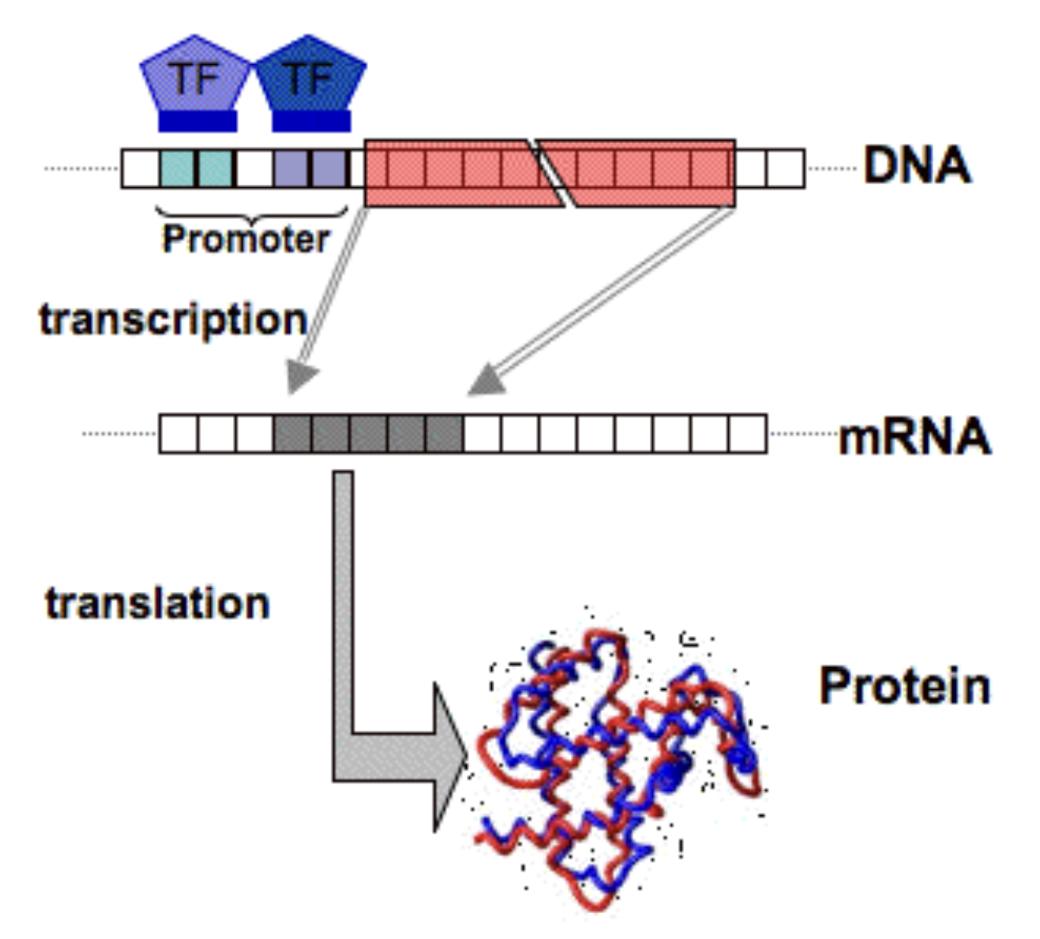
Figure 1. A simplified diagram of the Central Dogma of molecular biology. The promoter region, upstream of the gene in red, initiates transcription. The promoter region typically contains multiple motifs that are specific to a several regulatory proteins.

Therefore, understanding where TFs are active or potentially active in the genome is a crucial component of understanding how gene expression is encoded. Transcription factor activity is triggered by a region of DNA physically adjacent to the encoding gene; these regions of conserved DNA patterns are known as motifs.

Motif discovery is highly motivated by numerous practical applications such as diagnosing and treating chronic genetic diseases, targeted drug design, and toxicity prediction of peptides and proteins. On a grander scale, identifying motifs is a key component in computational modeling of transcriptional regulatory networks (TRNs), where multiple TFs and their target genes interact to modulate phenotypes and cell behaviors systematically within an organism. Bioinformatics aims to detect high-quality motifs to enable better understanding of how TFs interact across the genome and discover previously unknown targets, which in turn informs better models of cell states as a function of their genetic code.

While motif discovery is a highly motivated investigation in bioinformatics, the setting is inherently noisy as regulatory TFs tolerate variability in the sequences comprising the motifs. In other words, TFs are not strictly discriminative in the specific nucleotide sequence that they bind to. The biological context offers inherent noise challenges. Firstly, motifs can be degenerate, where only a few nucleotides within the motif are relevant to its function. This means TFs do not strictly discriminate for a specific, universally consistent and stable sequence of nucleotides: due to natural evolutionary mutations, TFs can still bind to sequences that look “close enough,” and this allowance for variation introduces an inherent baseline level of noise and uncertainty during the process of discovery. Moreover, de novo motif discovery – the process of finding motifs without prior sequence alignment – is further stymied by the fact that a motif’s location relative to its corresponding gene is unfixed. The motif can be either upstream or downstream of the gene, and the distance between the motif and the gene varies substantially. Therefore, motif discovery can be considered a common approximate substring (CAS) problem, which is characterized as NP-hard.

Classical approaches to motif discovery include ChIP-Seq (Chromatin Immunoprecipitation Sequencing) and RNA-Seq. In these wet-lab approaches, biologists grow the organism of interest in a petri dish. In ChIP-Seq, the transcription factor under investigation is bound to the DNA, after which the specific portions of DNA that attached to the TF are analyzed to report on which DNA patterns make up the motif. On the other hand, RNA-Seq approaches the task by exploiting the transcription stage of the Central Dogma, comparing an experimental cell sample where the TF of interest has been deleted or overproduced. Comparing the mRNA produced in the experimental sample to the control sample provides a snapshot of which genes were activated (or repressed) in response to the presence of the TF. In turn, the mRNA is sequenced and mapped back to the original genome, which elucidates the specific sequence of the genome that was transcribed by the TF. In other words, RNA-Seq offers a way to quantify the gene expression modulated by the TF.

However, both classical approaches are low-throughput and costly. Crucially, they are limited as the results for each wet-lab experiment are specific to one genome only, meaning that the task of distinguishing true functional motifs from random variations due to background mutations is stymied by poor statistical power and high false positive rates.

The alternative approach leverages comparative genomics and phylogenetic footprinting, which is predicated on the concept that if a TF regulates a specific gene in one species, it likely regulates orthologs (equivalent genes) in related species. In other words, if we assume a gene and the critical components of its motif sequence are conserved and thus largely similar across several evolutionarily related species, we can leverage the resulting larger sample size to detect true motifs across these species while filtering out noise from random natural variations and mutations. Zhang and Gerstein’s 2003 work “Of mice and men” explains that because regulatory elements like motifs are functionally important and are under evolutionary selection, they should have evolved much more slowly than other non-coding sequences, meaning they are more likely to be highly conserved over evolutionary timelines.

Several algorithms have been developed to perform ab initio motif discovery (i.e., from scratch) by applying comparative genomics to existing sequence databases. Motif discovery in silico allows for substantial reduction and refinement of the search space for more likely active binding site candidates, which in turn reduces the costs and cycle times of wet-lab testing to verify and understand their function.

To perform motif discovery, DNA sequence segments are typically modeled as matrix representations, which can then be analyzed through the information theory framework. Information theory was conceptualized as early as 1948 with Claude Shannon’s watershed “A Mathematical Theory of Communication,” which was then applied in the biological context by Lila Gatlin’s “The Information Content of DNA” in 1966. Thomas Schneider’s 1984 thesis formally applied information theory to TF binding sites, proposing that the information content inherent to binding sites is sufficient for such sites to be distinguished from the rest of the genome. In essence, all of these works are founded on the notion that DNA is considered an information-bearing message, and by comparing multiple sequences known to be bound by a particular transcription factor, we can infer the likely morphology of its binding motif by applying statistical detection of overrepresented patterns across the sequences.

Several approaches exploit the information-transmission nature of DNA sequences for motif discovery. Word-based combinatorial methods (also known as “enumerative”), as described in Pevzner and Sze’s “winnowing” algorithm, establish a dictionary of words comprised of all possible DNA sequence combinations of length l, with an assumed allowance of d mismatches within each word (e.g, ATGCGT and ATGCGA are the same "word" with a 1-letter mismatch). This method employs graph theory to connect each word as nodes, with edges defined by similarity under variation d. Words with more edges are likelier positive signals. While combinatorial word-based methods are exact in that they are guaranteed to find the globally optimum solution, their combinatorial nature makes them computationally expensive for longer motifs, as the quantity of all possible words in the dictionary scales exponentially.

Greedy algorithms seek to address the computation problem of combinatorial methods, as they are not guaranteed to find the global optimum, operating on iterative cycles that select locally optimum solutions at each iteration. These methods often use the probability weight matrix (PWM), which describes the frequency of each of the four nucleotides at each index given a set of observed DNA sequences.

Hertz and Stormo’s 1999 CONSENSUS is an example of this class of greedy algorithm. This algorithm iteratively performs increasingly larger group-wise matrix sequence comparisons, starting with a word of user-specified length n and a pairwise comparison that computes information content (IC) for sequences aligned to that length. Then, segments of the other observed sequences of length n are aligned with the first word, and the cycle continues, selecting for maximum IC. Unlike probabilistic algorithms, CONSENSUS is deterministic, in that its selection of best candidates does not rely on a stochastic process, being as it evaluates consistent paths that maximize IC.

Probabilistic algorithms are also greedy and address the combinatorial computation problem by leveraging stochastic behavior. Gibbs sampling and expectation maximization (EM) are key concepts employed by these algorithms. EM uses a semi-random candidate subsequence of length n and computes the probability that this subsequence was generated by the PWM, iteratively improving the seed to maximize the candidate’s conditional probability given the observed data. Gibbs sampling is conceptually similar, though it takes a stochastic approach. While EM operates on a weighted average across all subsequences, Gibbs sampling allows for weighted sampling where poor candidates can still be selected during the iterative process, thereby reducing the problem of getting stuck in a local optimum by introducing randomness.

MEME (Multiple EM for Motif Elicitation) is a popular implementation of an EM algorithm. It can locate short overrepresented sequence patterns in sets of sequences targeted by a transcription factor, but they generate multiple possible candidates with a variety of nucleotide sequence patterns and morphologies. Based on an architecture proposed by T.L. Bailey and Elkan in 1994, MEME’s core mechanism uses the position weight matrix of nucleotide frequencies (Adenosine, Thymine, Cytosine, and Guanine) at each index position to fit a mixture model. An iterative optimization process maximizes the model's likelihood to discover motif candidates of a user-specified length. Once a motif model converges, MEME evaluates its statistical significance by calculating an E-value, which represents the expected number of motifs with an equal or higher information content that one would find by pure chance in a random dataset of the same size.

Since the advent of MEME, several alternative toolkits such as HOMER (Hypergeometric Optimization of Motif EnRichment, 2010) or STREME (Simple, Thorough, Rapid, Enriched Motif Elicitation, 2021) pursue de novo motif discovery with different approaches, using tokenization and suffix trees to improve scaling ability, user friendliness, and accuracy.

Other approaches are machine learning based. Genetic algorithms form the basis of methods like FMGA (“Finding Motifs by Genetic Algorithm), which simulates a natural selection-like mechanism driven by a fitness function which scores and prunes randomly selected candidate motifs on similarity to the observed promoter sequences. Other methods like KEGRU use recurrent neural networks to map the potential candidate sequence segments into vector representations. Other machine learning algorithms use hierarchical LSTM (Long Short-Term Memory), time series, and deep learning. A notable example of a deep-learning framework is DESSO, which integrates DNA shape feature detection to improve precision compared to five other methods, including deep learning-based and MEME-ChiP algorithms.

Applying the Bacterial Context

Across all these methods of in silico motif discovery, an algorithm output’s statistical significance (e.g. the E-values of found candidates) does not automatically equal biological significance. Seemingly compelling motif candidates can simply be reflections of background noise and chance repeats in the sequence.

Incorporating domain-specific knowledge heuristics related to TF structure can help refine outputs further. Many bacterial transcription factor proteins form dimers, more specifically through homodimerization, meaning two identical TF molecules form pairs that confer advantages such as increased specificity to targets. Dimeric bacteria can be oriented in a manner that is head-to-head or head-to-tail, and this impacts the sequence morphology of the motifs they bind to. Head-to-head TFs are oriented in a mirror fashion with 180-degree symmetry facing each other, meaning they can bind to palindromic motifs (i.e., the motif is a “reverse complement” pattern such as ATGC…GCAT). As DNA is double-stranded, the head-to-head orientation of the TF allows it to operate on both the top and bottom strand. On the other hand, head-to-tail homodimers, by nature of their orientation, tend to bind to symmetrical motifs as their singular orientation only allows them to transcribe unidirectionally on the same strand of DNA (such as GTTC…GTTC).

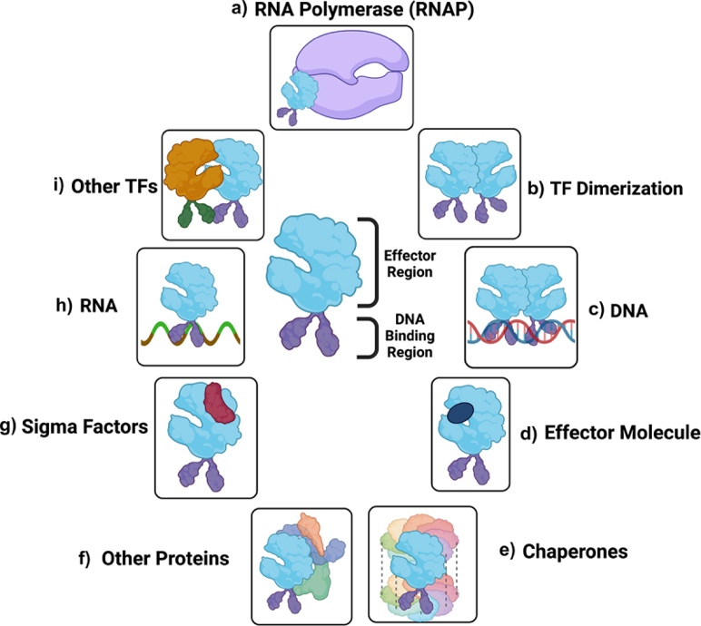
Fig. 2: Diagram part b) shows an example of TF homodimerization, where two identical TFs are paired together head-to-head.

The dimerization property of bacterial TFs can therefore be applied to evaluate the plausibility and quality of the outputs of various motif discovery algorithms. By focusing on the domain of well-studied bacteria TFs with known dimeric behaviors, we can evaluate the specific sequence morphology of potential motif candidates to create measures of quality – i.e., a measure of how “palindromic” a candidate motif is.

Objectives

The objective of this thesis is to create statistical frameworks that assess and justify which candidate motifs reported by discovery tools like MEME are more likely to be true TF-binding motifs.

Assessing the comparative quality of motif candidates is an iterative step serving as a noise filter to prioritize candidates for further investigation. Rather than introducing a new methodology for de novo discovery, of which there are many as discussed earlier, the goal is to design a data pipeline that refines and evaluates the motif candidate group.

Given a set of binding site sequences across the FNR-CRP, LexA, and OmpR transcription factor families from CollecTF, we establish a data pipeline that outputs a statistical evaluation of the quality of the motif candidate, incorporating the direct repeat and palindromic properties of the bacterial domain as a guiding heuristic. We will employ the matrix representations of the aligned sequences (the position weight matrix) to model their joint distributions and assess the bootstrap distribution plausibility of the candidates.

Methodology and Development

Two sources for data:

- a collection of aligned sequences from the CollecTF database, consisting of 52 unique transcription factors across multiple species. The sample size is 68 some of the TFs are common across multiple species.
- A collection of four MEME outputs, each of which contains 10 candidate motifs.

Both are manually labeled for the kind of pattern they are (inverted direct repeat etc.) based on visual inspection or based on established literature consensus.

At the start of the analysis, the principal method of evaluating motif quality is with a self-comparison matrix of the PWM. We use the Shannon Information Content and also incorporate various measures of distance and concordance.

- Self-comparison matrix
- Various concordance metrics (PIC, Pearson correlation, Jensen Shannon, PIC – JSD hybrid metric)

These metrics are used to visualize the motif pattern – direct and inverted (or reverse, or palindromic – used interchangeably) repeats, where direct repeats have high concordance and inverted repeats have high concordance when the second half of the motif is reversed and complemented.

After defining the key concordance metrics and target mechanism for motif pattern visualization, we define a scoring pipeline to determine candidate size. This is a user parameter but we use an adaptive percentile threshold-based and motif size argument to control.

Finally, we evaluate the results compared to the manual labels as well as discussing the behavior of the outputs when manipulating the user-defined parameters.

Results and Discussion

- Individual observation comparison -- Adjusting the threshold impacts the motif size, result quality, and computing overhead – lots of false positives but p-value significance
- Discuss a few exceptions, limitations of sample size
- ROC AUC as one aspect that measures concordance with manual annotations only
- More details on the direction of the p-values and error rate in aggregate when changing parameters

Conclusions
- applications in comparative genomics

Bibliography

https://www.sciencedirect.com/topics/veterinary-science-and-veterinary-medicine/transcription-factor
https://pubmed.ncbi.nlm.nih.gov/35199457/
https://www.researchgate.net/figure/Transcription-and-translation-process-The-picture-shows-the-transcription-factors-TF_fig7_249656139 https://pmc.ncbi.nlm.nih.gov/articles/PMC8523640/ https://pubmed.ncbi.nlm.nih.gov/15857245/
https://www.mdpi.com/1424-8220/22/3/1204 https://journals.plos.org/plosone/article?id=10.1371/journal.pone.0073957
https://pmc.ncbi.nlm.nih.gov/articles/PMC4943455/ https://pmc.ncbi.nlm.nih.gov/articles/PMC2673723/ https://www.sciencedirect.com/science/article/pii/S2001037021003597
https://pmc.ncbi.nlm.nih.gov/articles/PMC9779669/
https://www.mdpi.com/1424-8220/22/3/1204
https://bio.libretexts.org/Bookshelves/Computational_Biology/Book%3A_Computational_Biology_-_Genomes_Networks_and_Evolution_(Kellis_et_al.)/17%3A_Regulatory_Motifs_Gibbs_Sampling_and_EM/17.02%3A_Introduction_to_regulatory_motifs_and_gene_regulation
https://bio.libretexts.org/Bookshelves/Computational_Biology/Book%3A_Computational_Biology_-_Genomes_Networks_and_Evolution_(Kellis_et_al.)/17%3A_Regulatory_Motifs_Gibbs_Sampling_and_EM/17.02%3A_Introduction_to_regulatory_motifs_and_gene_regulation
https://doi.org/10.1016/S0304-3975(03)00320-7
https://pmc.ncbi.nlm.nih.gov/articles/PMC6981605/
https://pmc.ncbi.nlm.nih.gov/articles/PMC4863231/
https://pubmed.ncbi.nlm.nih.gov/24853928/ https://pubmed.ncbi.nlm.nih.gov/19844228/
https://pmc.ncbi.nlm.nih.gov/articles/PMC193683/
https://pmc.ncbi.nlm.nih.gov/articles/PMC193683
https://academic.oup.com/bioinformatics/article/37/18/2834/6184861?login=false
https://journals.plos.org/plosone/article?id=10.1371/journal.pone.0073957
https://onlinelibrary.wiley.com/doi/10.1002/j.1538-7305.1948.tb01338.x https://pmc.ncbi.nlm.nih.gov/articles/PMC1538977/
https://pubmed.ncbi.nlm.nih.gov/3525846/
https://pubmed.ncbi.nlm.nih.gov/10977088/
https://pubmed.ncbi.nlm.nih.gov/10786309/
https://pubmed.ncbi.nlm.nih.gov/10487864/
https://bio.libretexts.org/Bookshelves/Computational_Biology/Book%3A_Computational_Biology_-_Genomes_Networks_and_Evolution_(Kellis_et_al.)/17%3A_Regulatory_Motifs_Gibbs_Sampling_and_EM/17.03%3A_Expectation_maximization https://pubmed.ncbi.nlm.nih.gov/16900144/
https://pubmed.ncbi.nlm.nih.gov/16900144/
https://academic.oup.com/nar/article/34/suppl_2/W369/2505578
https://pubmed.ncbi.nlm.nih.gov/7584402/
https://pmc.ncbi.nlm.nih.gov/articles/PMC1538909/ https://pubmed.ncbi.nlm.nih.gov/7584402/
http://homer.ucsd.edu/homer/ https://academic.oup.com/bioinformatics/article/37/18/2834/6184861
https://journals.plos.org/plosone/article?id=10.1371/journal.pone.0095148 https://www.mdpi.com/1424-8220/22/3/1204
https://ieeexplore.ieee.org/stamp/stamp.jsp?tp=&arnumber=1317378&tag=1
https://www.nature.com/articles/s41598-018-33321-1
https://www.mdpi.com/1424-8220/22/3/1204#B42-sensors-22-01204
https://academic.oup.com/nar/article/47/15/7809/5542889
https://pmc.ncbi.nlm.nih.gov/articles/PMC11970743/
https://academic.oup.com/bib/article/25/6/bbae581/7900218
https://pmc.ncbi.nlm.nih.gov/articles/PMC3370831/
https://pmc.ncbi.nlm.nih.gov/articles/PMC1538909/
https://academic.oup.com/database/article/doi/10.1093/database/baw055/2630369?login=false#47326445

